W10- PRACTICE
FIREBASE (REST API)

 Learning objectives
- Handling a HTTP PUT to update an existing data element
- Handling an IN-MEMORY CACHE on repositories
- Handling HTTP POST to add new data element

How to start?
- Copy the START CODE into your current repository and push it
W10 - Start Code

- Each task of this practice shall be related to commit(s) including the tasks ID.
W10 -01 – Fetch and display songs

How to submit?
- Once finished, submit on MS Team
  - Your GitHub repository URL
  - This document if needed



This practice focusses more on clean code structure rather than Flutter technical skills.
We will evaluate how well you follow the coding conventions, how your name your class, variables etc.

No code generated by AI is allowed

W10-01 – Handle the like-a-song button

We want to be able to like a song by clicking on below like buttons.
Note: we don’t care about who liked the song (no user id needed), but just a simple counter.

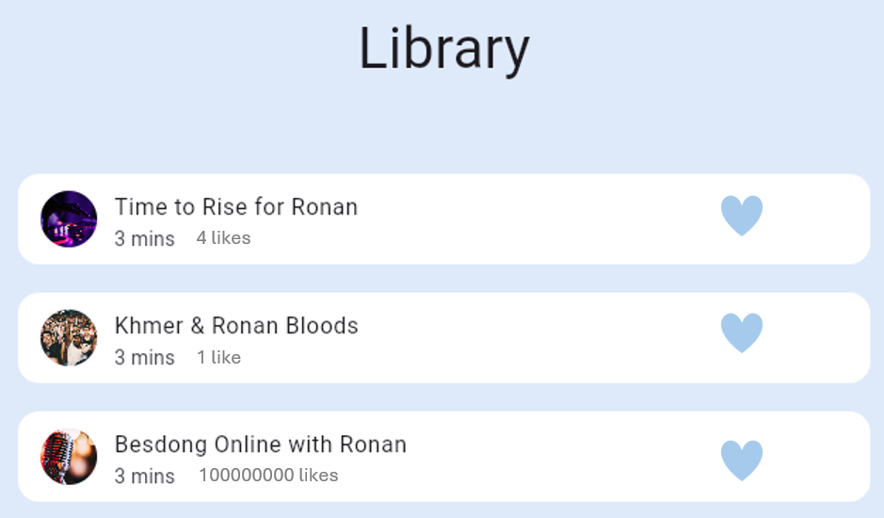

❓ Firebase DB: How will you update your Firebase database to handle the number of likes?

❓ HTTP Request: What kind of HTTP verb will you choose to increment the likes?

❓ Repository: Propose a method in the Song Repository to handle liking a song
- What should the method parameters be? (e.g., song ID, full Song object, current number of likes?)
- What should the method return? (e.g., Future<void> or Future<Song>?)
- What should be the possible errors?

❓ Model View:
- How will you update the model view AsyncValues ?
- What will you do in case of error?

❓ View:
- What kind of screen or screen need to be updated?
- What will you do in case of error?

W10-02 – Handle In-Memory Caches

We want to handle in-memory caches on each repositories

The repository sits between:
- The data source (API, DB)
- The application logic / UI

So it’s the perfect place to:
- avoid duplicate API calls
- keep already-fetched data alive during app usage

A basic template to handle a cached value in the repository could be:
List<X>? _cachedXX;
Future<List<Song>> getXX() async {
// 1. Return cache if available
if (_cachedXX!= null) {
return _cachedXX!;
}
// 2. Otherwise fetch from API
final xx = await _fetchXXs();
// 3. Store in memory
_cachedXX = xx;
return songs;
}

Q1 - Implement caches in the different repositories (Song, Artist)

Q2 – Add a RefreshIndicator widget to force the refresh (clear the cache)
https://api.flutter.dev/flutter/material/RefreshIndicator-class.html

Note you can update the repository API with an option to force the fetch:
Future<List<Song>> getXX({bool forceFetch = false}) async

Q3 – We can still see a very fast tiny “loading flash”: can you explain why?
TIP: think about the view model lifecycle, when are we creating it?

W10-03 – Artist Screen with Songs and Comments

⚠️ For this task, you are allowed to get some guidance with AI to code faster (if you want).

We want to create another screen for a specific artist
- Displays a list of songs for a given artist
- Allows the user to post a comment about the artist

1️⃣ Model Layer
- Create the Comment model
- Update the Artist model (e.g., add new fields if needed)

2️⃣ DTO / Repository Layer
- Update the Artist DTO (if necessary for songs/comments)
- Update or create the Artist Repository methods:
- Fetch artist songs
- Fetch artist comments
- Post a new comment

3️⃣ ViewModel
- Create Artist VM
- Add state variables:
  - List<Song> songs
  - List<Comment> comments

- Implement fetchData() → fetch songs and comments
- Implement addComment() → post new comment, update local state, notify listeners

4️⃣ UI Layer — Screen & Widgets
- Create Artist Screen
- Re-use existing SongTile widget to display songs
- Create CommentTile widget to display comments
- Show placeholders for empty song or comment lists

- Create Comment form:
  - Text field + submit button
  - Placed in a bottom navigation panel or bottom sheet
  - Clear comment input after submitting a comment
  - Validate empty comments before posting

